Kabasomi of Kinyinya school for the Deaf gave ears and voice to Kyegegwa’s deaf pupils
By Vision Reporter
Added 20th December 2012 02:46 PM
The birth of a child brings joy to every parent. “I had never felt happier. I was so excited,” says Florence Kabasomi, a teacher from Kyegegwa district.
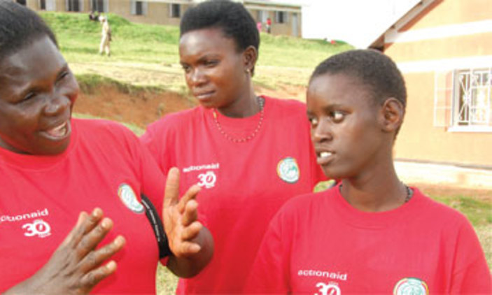
By Joel Ogwang
The birth of a child brings joy to every parent. “I had never felt happier. I was so excited,” says Florence Kabasomi, a teacher from Kyegegwa district.
However, at times, we are not prepared for what these bundles of joy might bring with them. That is exactly what happened to Kabasomi in 1988. Little did this Grade III teacher know that her daughter was deaf as she did not realise the anomaly until years later.
Deafness can be accurately diagnosed only when a child reaches four years of age. In some cases, it is not confirmed until a child is eight years old. The condition impedes the speech and social and intellectual development of such children.
When it was time for Kabasomi’s daughter, Sylivia Atuhurra, to start school, there was none that catered for the deaf both in the neighborhood.
“I was forced to learn sign language so I could teach my daughter from home. I started the classes in 1991,” says Kabasomi.
But Atuhurra had to later get enrolled for formal education. Kabasomi struggled to make her child’s dream of getting an education come true. Her sacrifice and unrelenting efforts paid off when, in 1998, Atuhurra became the first deaf pupil to sit Primary Leaving Examination in the area.
She scored Aggregate 29. This was not the best performance, but it was worth it, considering the several years of home schooling, with her mother as her only teacher.
“At the time, parents were ashamed of deaf children,” says Kabasomi. With no secondary school for the deaf in Kyegegwa, Atuhurra could only enroll for vocational education, studying tailoring after her Primary Seven.
Years later, the 24-year-old is working as an office attendant at the Actionaid &UNAD offices in Fort Portal.
Atuhurra’s success strengthened Kabasomi’s resolve to fight for deaf children. A unit for the deaf was set up at her school and Kabasomi helped run it. In 1999, she also helped open another unit at Kinyinyi Primary School, with five pupils that has transformed to a full school for deaf children
When it was officially launched four years later, its enrollment was 19 pupils. Today, the school has 76 pupils. The school takes care of deaf children from Kyegegwa, Kiruhura, Kasese, Kabarole, Mubende, Kibaale and Kyenjojo districts.
“We appreciate what Kabasomi has done for the deaf and for not giving up on her daughter,” says Emmanuel Kamihanda, the Kinyinyi Primary School head teacher.
“Her example helped reduce the stigma children with disabilities suffered.” Kabasomi’s efforts were rewarded when Action Aid International-Uganda (AAIU) and the Uganda National Association of the Deaf and Kyegegwa Deaf Development Programme.
The project promotes education of deaf children through empowering communities, increasing household income and supporting the construction of schools for the deaf.
Not only has Kabasomi nurtured and mentored deaf pupils at Kinyinyi Primary School, she has also awakened their dreams. “I want to study medicine at university,” says Milton Biryomumaiso, a Primary Six pupil, speaking through an interpreter.
To Agnes Kamukama, 18, a Primary Seven leaver, Kabasomi is more than a teacher. “I call her a relative and a friend because she also knows my family and treats me well.”
Kabasomi’s tireless and selfless efforts to help the deaf have seen her return to school to upgrade her academic qualifications.
Today, she holds a bachelor’s degree in education in special needs education from Kyambogo University. Despite her academic qualifications, she still teaches in a primary school. She is a role model to fellow teachers.
“She is friendly, but strict on what she intends to do,” Living Businge, a special needs teacher, says. “She is the embodiment of a great teacher. Kabasomi is my role model and inspires me to upgrade into a better teacher.”
Kabasomi also knows that her effort is paying off. “I am happy that parents now bring their deaf children to school willingly,” says Kabasomi.
“If you hate your child, who will love him or her? Deaf children are born after nine months like all the other children. The only difference is that they have a hearing impairment.”
Plans are underway to transform the unit into a fully-fledged primary school, despite the many challenges it is facing.
Of the deaf pupils at the unit, 23% are orphans, making accommodation a huge problem. As a result, boys share the same dormitory with girls.
“We need a borehole because the only water point is far. This endangers the pupils’ lives as they cannot cross the road without help.” But, there is hope and some progress has been attained. A multi-million vocational centre and dining hall funded by AAIU were recently launched to commemorate the charity’s 30 years of existence.
Kabasomi dreams of a day, when the deaf and children with disabilities will be welcomed into the world with joy and treated like any other child.
Kabasomi of kinyinya school for Deaf gave ears and voice to Kyegegwa’s deaf pupils

